# What is a Kubernetes cluster?

In distributed computing cluster is a high availability solution that distribute loads between the nodes.

A Kubernetes cluster is a set of node machines for running containerized applications. If you’re running Kubernetes, you’re running a cluster.

At a minimum, a cluster contains a control plane and one or more compute machines, or nodes. The control plane is responsible for maintaining the desired state of the cluster, such as which applications are running and which container images they use. Nodes actually run the applications and workloads.

What is Pod?

pod is group of containers with shared networking and storage resources.

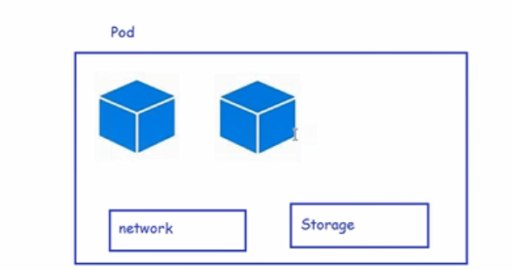

Digging inside Pod

* This is smallest deployable units of computing in k8s
* A Pod consists of one or more containers with shared network and storage resources
* Each Pod will receive a unique ip address
* To create any object in k8s we need to create a template
* To write the spec navigate to api reference (<https://kubernetes.io/docs/reference/generated/kubernetes-api/v1.19/>)
* pods specs created(<https://github.com/asquarezone/KubernetesZone/commit/2cd30bd9cb16740c2731c231cd8e4caee10744c7>)
* Now let’s try to apply the pod spec created



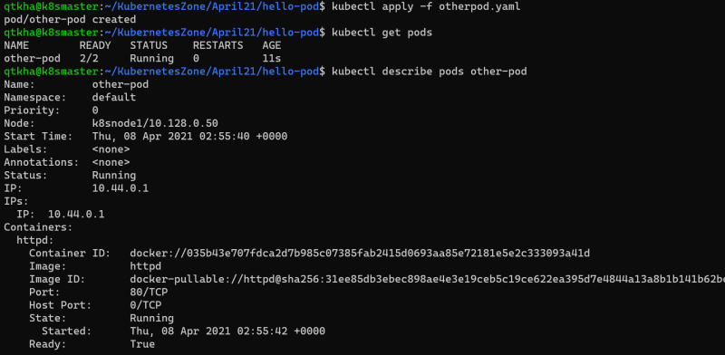

Each pod will get one ip address 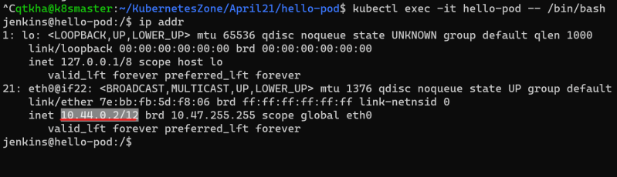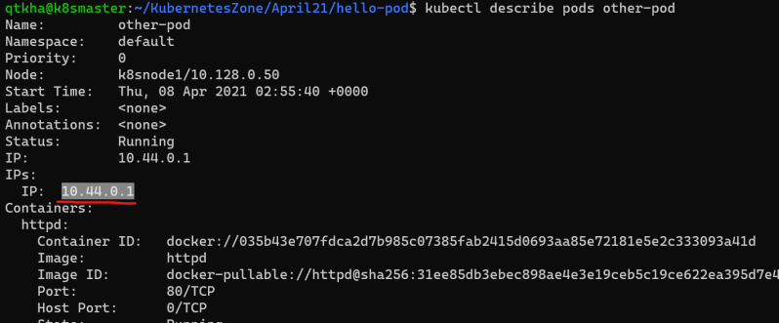

Kubernetes namespace

* K8s supports multiple virtual clusters backed by same physical cluster and these virtual clusters are called as namespace
* In k8s for any object we have two kinds of scopes
  + cluster scope
  + namespace scope

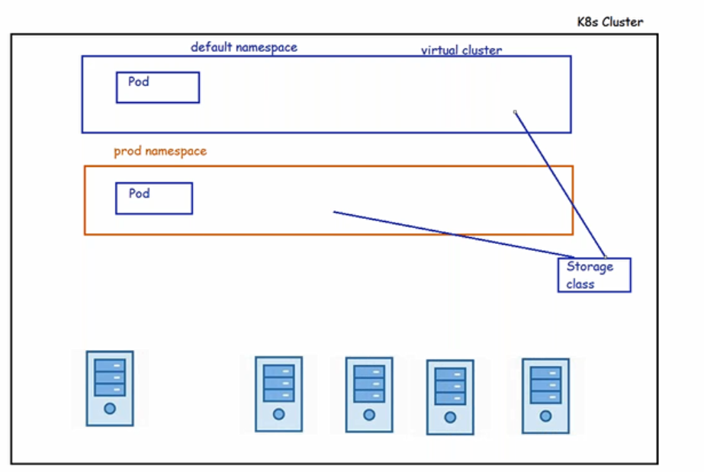

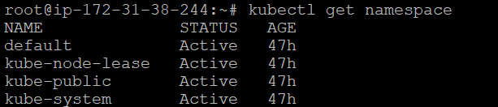

Kube-system and kube-public namespace are used for cluster internal communication.

Commonly used kubectl commands

* get object: In the resources which are scoped to namespace we can use -n to specify the namespace

kubectl get pods -n default

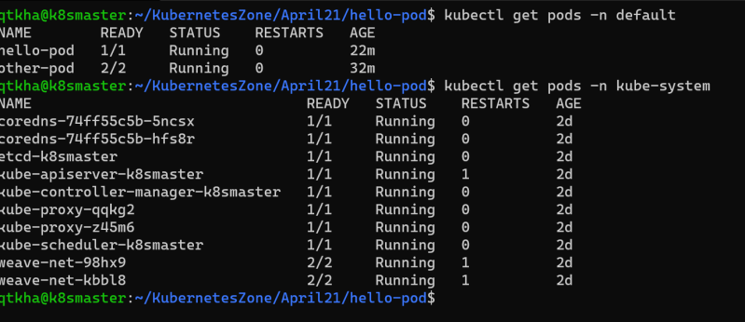

describe object-type object-name

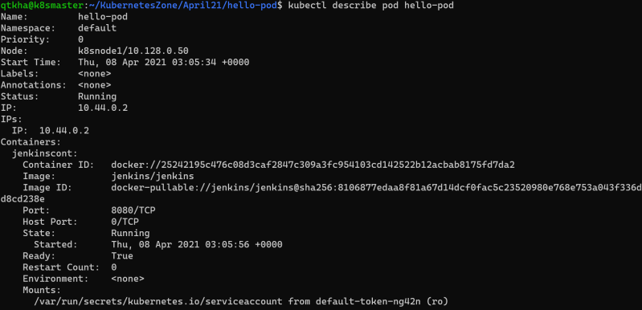

logs object-name

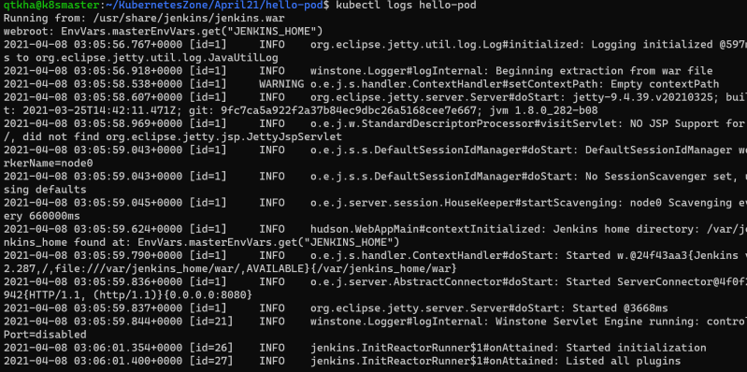

apply -f filename. Yaml

Other Commands 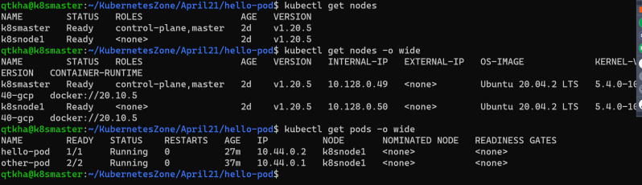

We can use short names 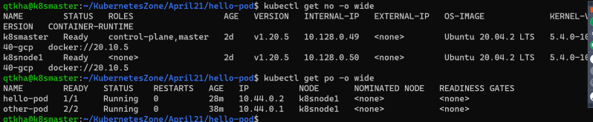

To get to know the information of cluster 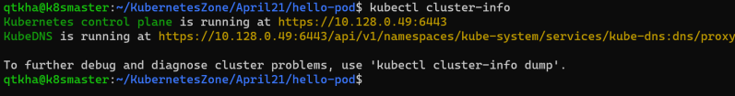

Kubernetes HTTP Request Flow

* HTTP Request flow 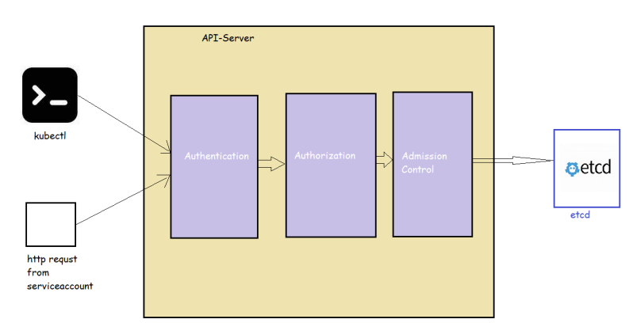
* Restful api: It provide the way to connect different platform to connect my application.

The K8s API

* K8s api uses JSON over http for its requests and responses.
* k8s api allows clients to create, update, delete or read the description of object via standard http methods 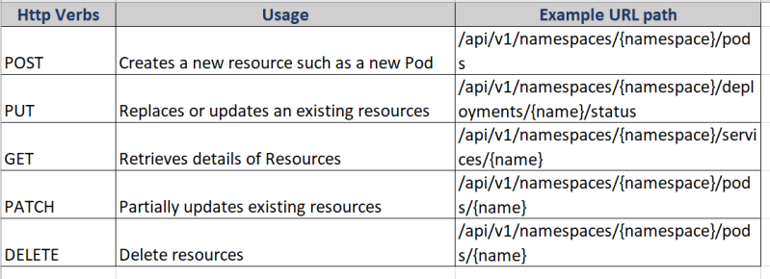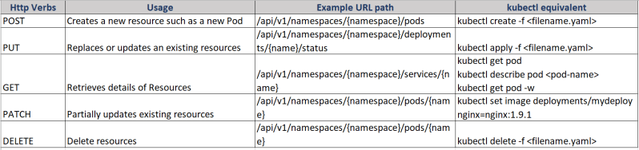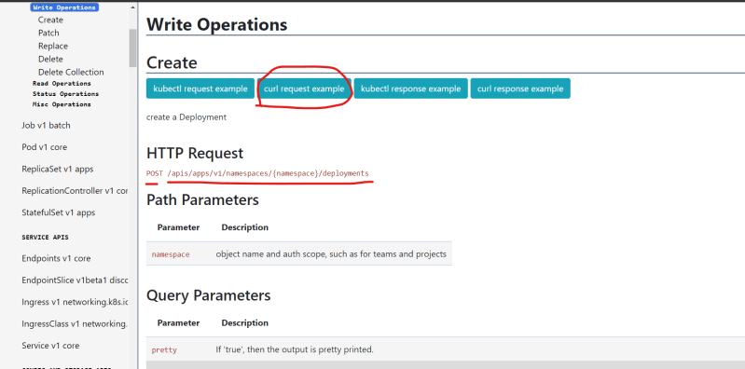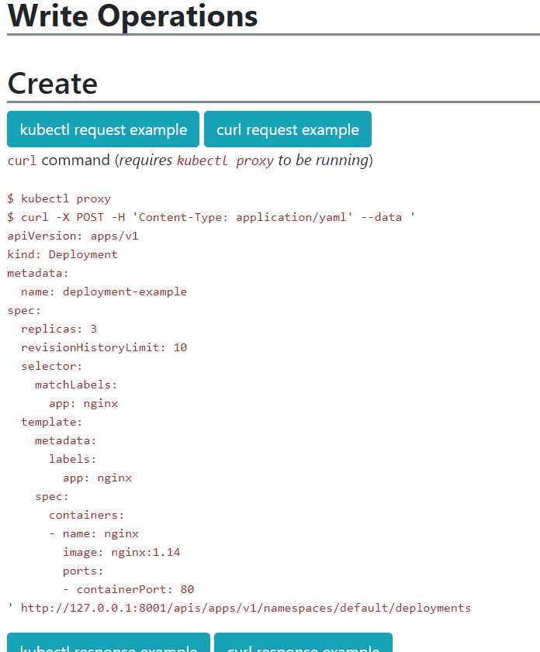

Trace the HTTP requests: To trace http request we will be using kubectl get pods -n kube-system. To this we will be adding verbose level –v=8

kubectl get pods -n kube-system --v=8

